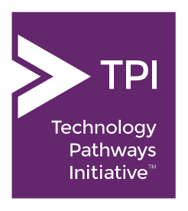
Technology Pathways Initiative
Fact Sheet

Mission | TPI brings together university faculty and high tech industry leaders committed to helping more college women excel in technology fields, through interdisciplinary computing education, from campus to career.
Challenge | By the year 2026, the U.S. will have 0.9 million computing job openings, but only 560,000 Computer Science Bachelor’s graduates to fill them.¹ This workforce gap is exacerbated by a gender gap: women make up 58% of all college graduates, but only 18% of graduates with computing degrees. In the San Francisco/Silicon Valley region, our public universities are major suppliers of local talent to the workforce. By closing these gaps, we can strengthen our workforce, drive technological innovation, and fuel economic growth.
Key Players | Universities spearheading TPI include U.C. Berkeley, U.C. Davis, U.C. Davis, U.C. Riverside, San Francisco State University, San José State University, and California Polytechnic State University, San Luis Obispo. Founding corporate sponsors include Intel Corporation, KLA-Tencor Foundation and Salesforce. The aim of TPI is to have a total of ten universities and five sponsors by 2019. The Center for Advancing Women in Technology (CAWIT) provides a platform for community and collaboration for TPI.
Model for Systemic Change | TPI faculty champions are creating new interdisciplinary programs that integrate computing with fields of study such as biology, mathematics, statistics, and cognitive sciences that already have high female student enrollment. These fields continue to evolve and expand through innovative applications of technology.  Each new program begins with a cohort of students who study computing as part of their college degree program. Cross-campus collaboration and sharing of new curricula and teaching methods help ensure a scalable and replicable model that can be adapted by other public universities, all of which serve large and diverse student populations.  High tech industry sponsors are funding the development and implementation of these TPI pilot programs, after which the programs will become self-sustaining.
Timetable and Goal | The Technology Pathways Initiative was launched in 2015. Its goal is to produce twice as many women graduates with computing degrees per year beginning in the 2020-2021 academic year.  Learn more at cawit.org.  ¹U.S. Bureau of Labor Statistics

